ASSIGNMENT 3(DMSL)
Table 1: Students
Columns:
• StudentID (Integer, PRIMARY KEY, NOT NULL)
• FirstName (VARCHAR(50), NOT NULL)
• LastName (VARCHAR(50))
• Email (VARCHAR(100), UNIQUE)
• DOB (DATE, NOT NULL)
• CourseID (Integer, FOREIGN KEY references Courses(CourseID))

Table 2: Courses
Columns:
• CourseID (Integer, PRIMARY KEY, NOT NULL)
• CourseName (VARCHAR(100), NOT NULL, UNIQUE)
• Credits (Integer, DEFAULT 3)

3. Insert records into the tables while ensuring the constraints are not violated.
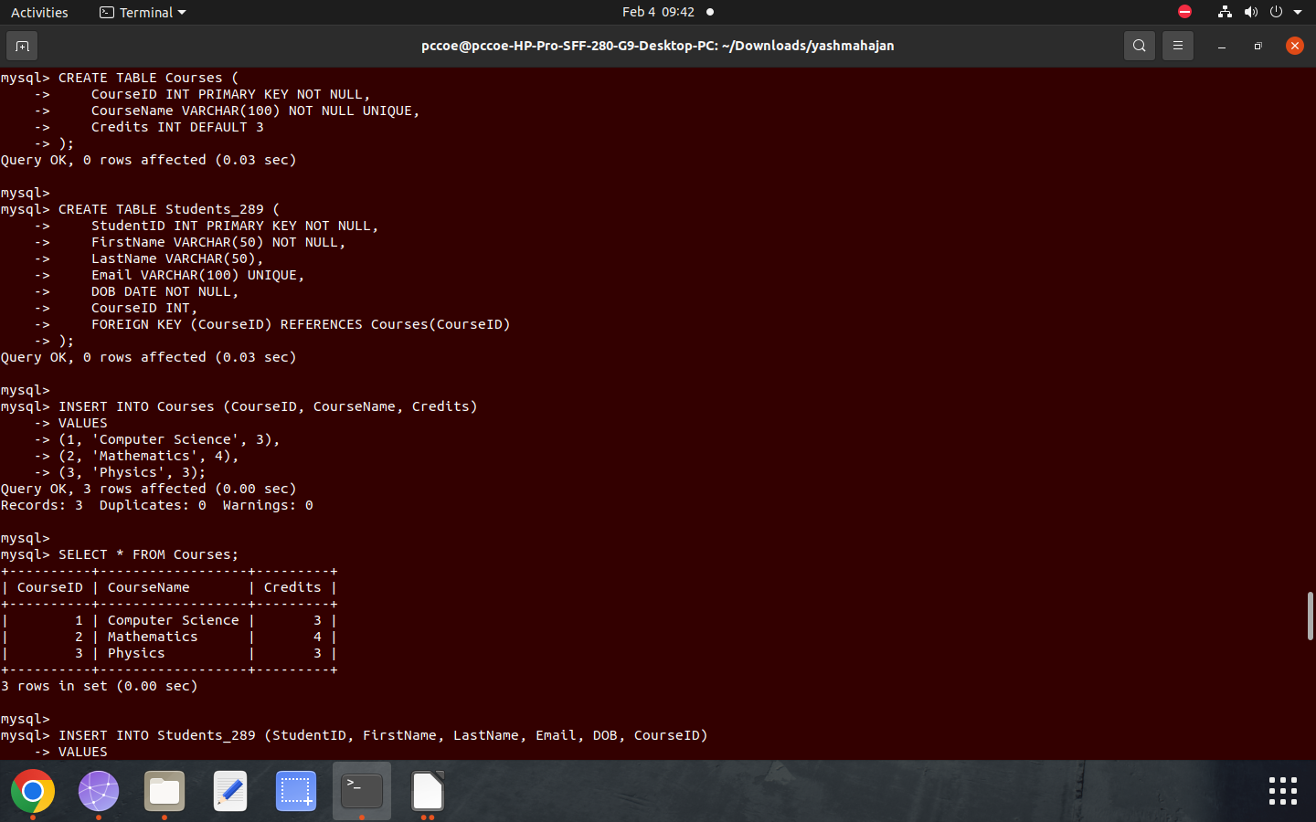
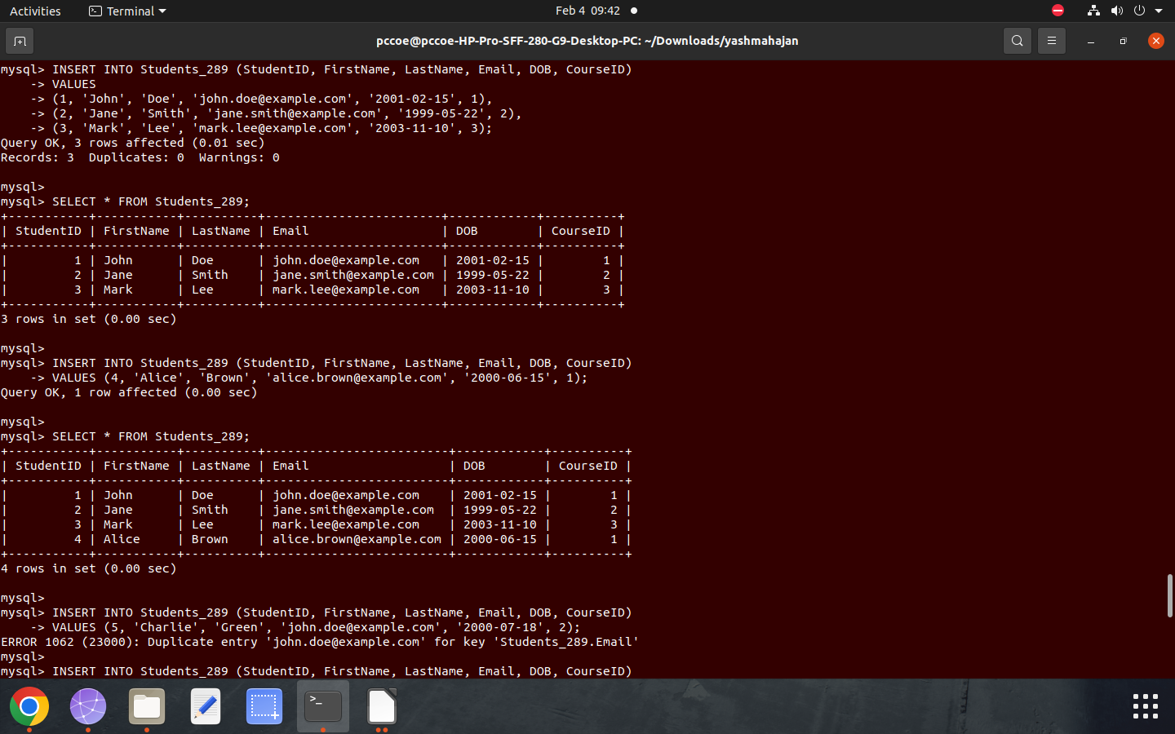

4. Test the Constraints
Attempt to violate the constraints and observe the results:

1. Test 1: Insert a NULL value into a NOT NULL column.
2. Test 2: Insert a duplicate value in the UNIQUE column.
3. Test 3: Insert a record with an invalid FOREIGN KEY reference.

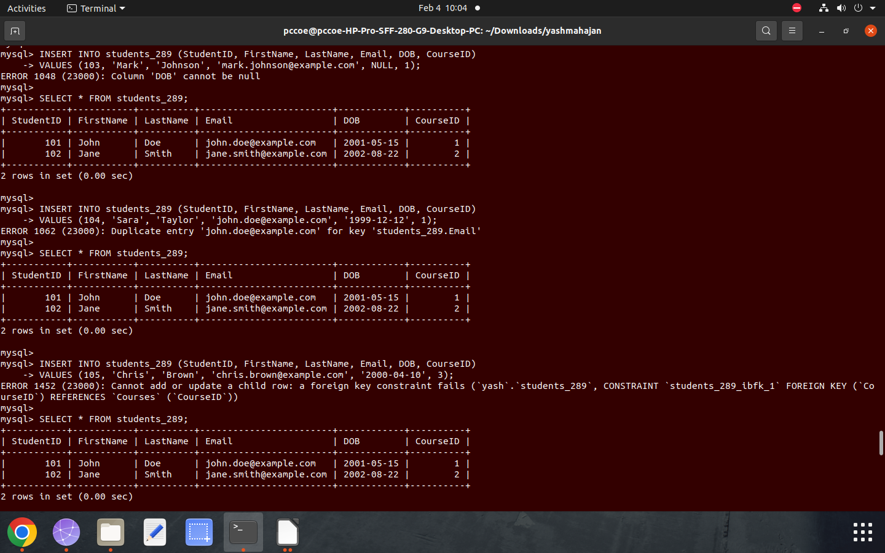
5. Attempt following questions:

1. Write a query to display the names of students who were born after the year
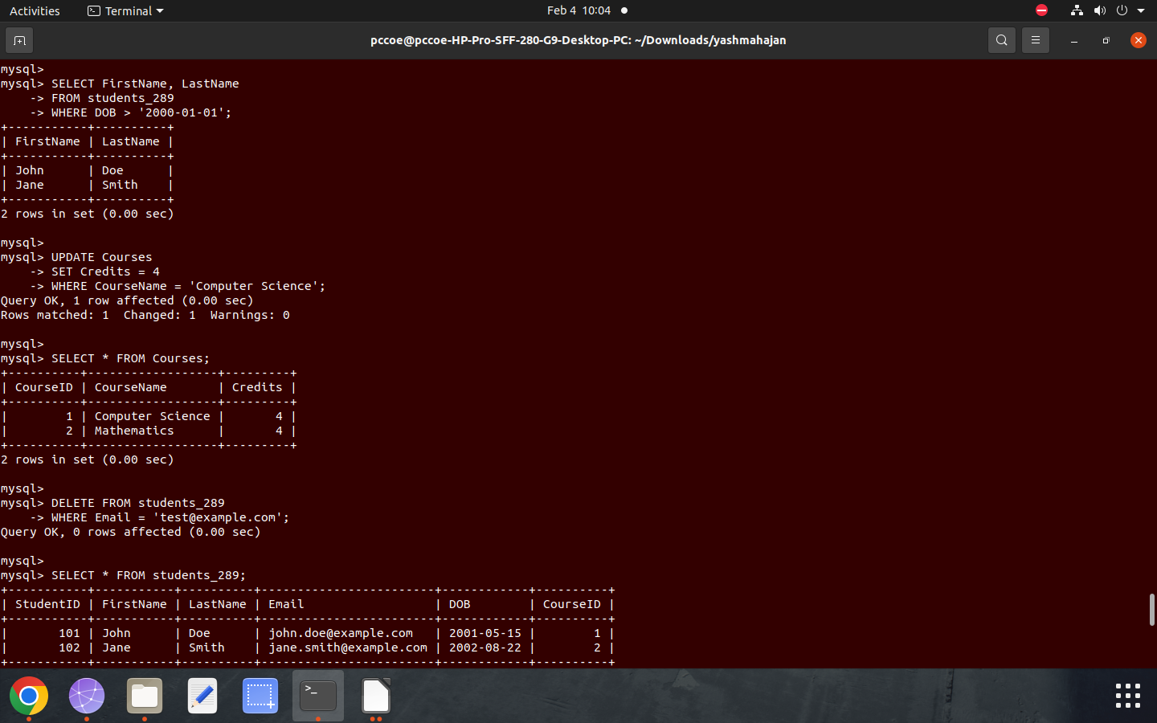
2000.

2. Write a query to update the course credits for "Computer Science" to 4.



3. Write a query to delete a student record whose email is 'test@example.com'.


4. Write a query to find students who are not enrolled in any course.
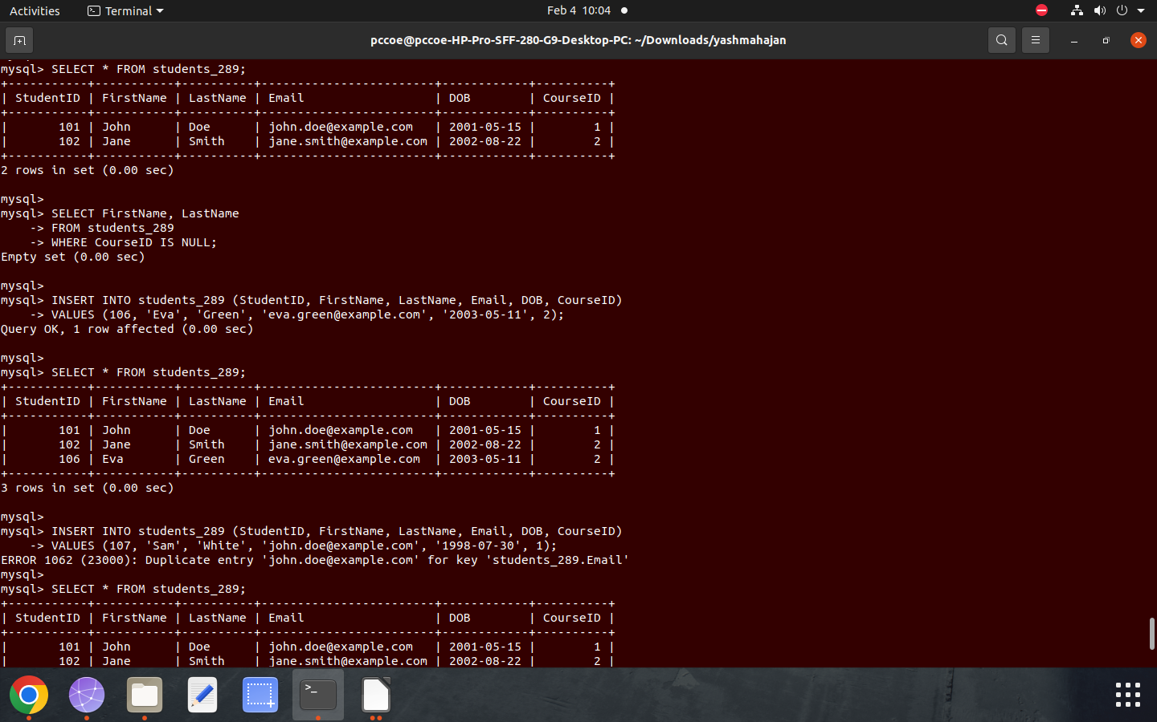
5. Test the UNIQUE constraint by inserting a duplicate email into the Students
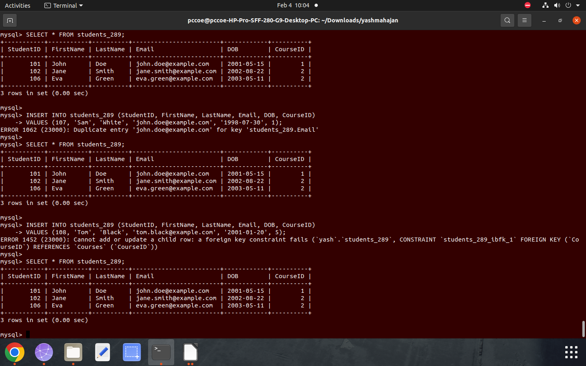
table
6. Test the FOREIGN KEY constraint by inserting a student with a CourseID
that does not exist in the Courses table


